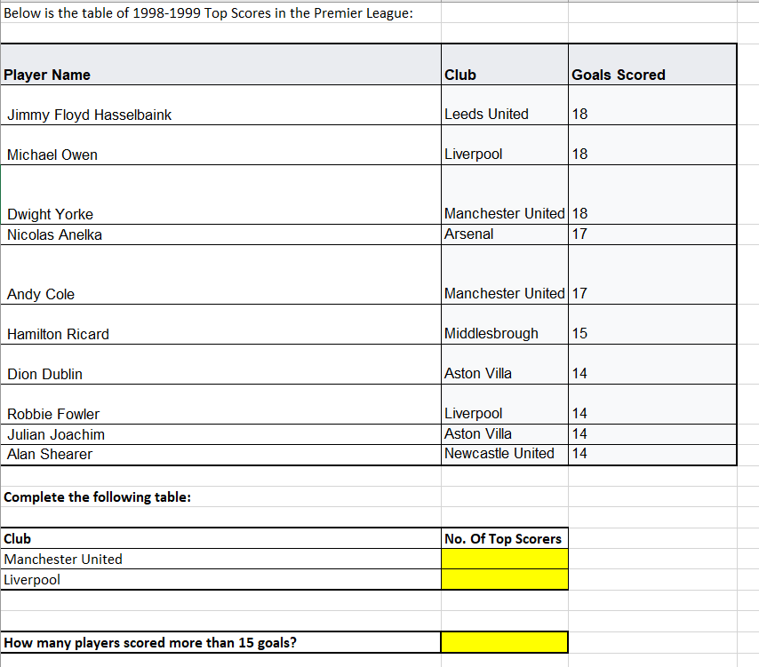

2.

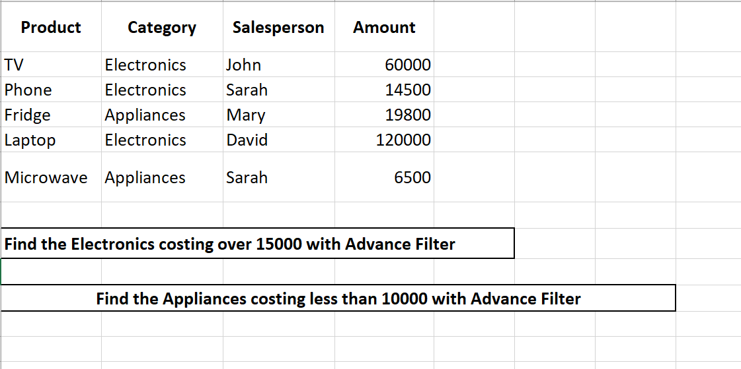

3.

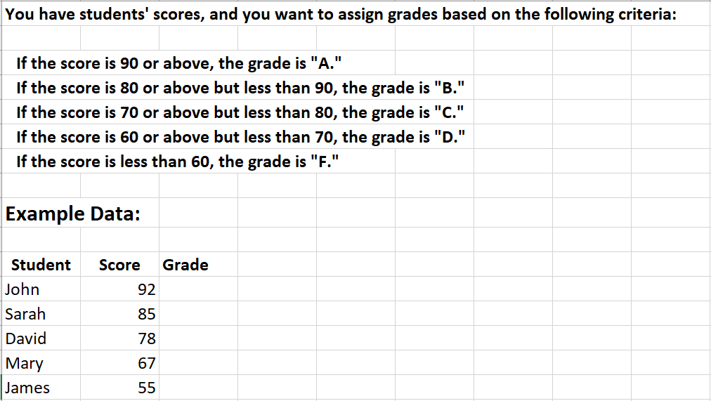

4.

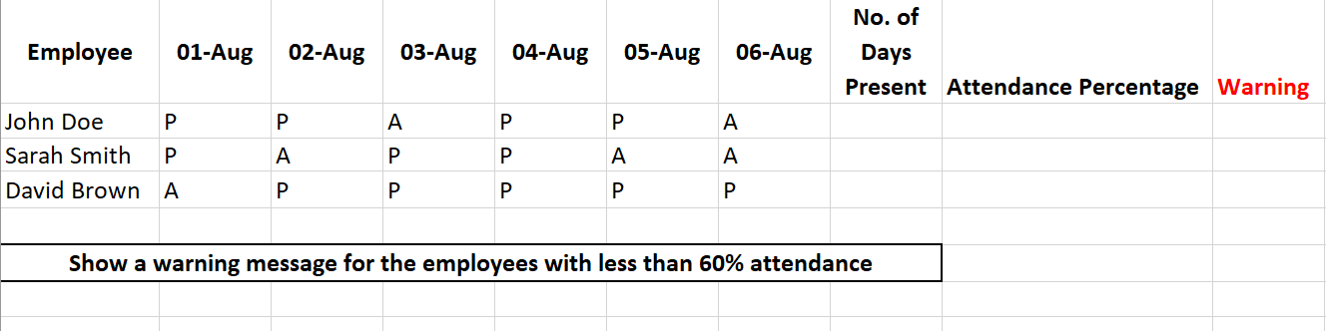

5.

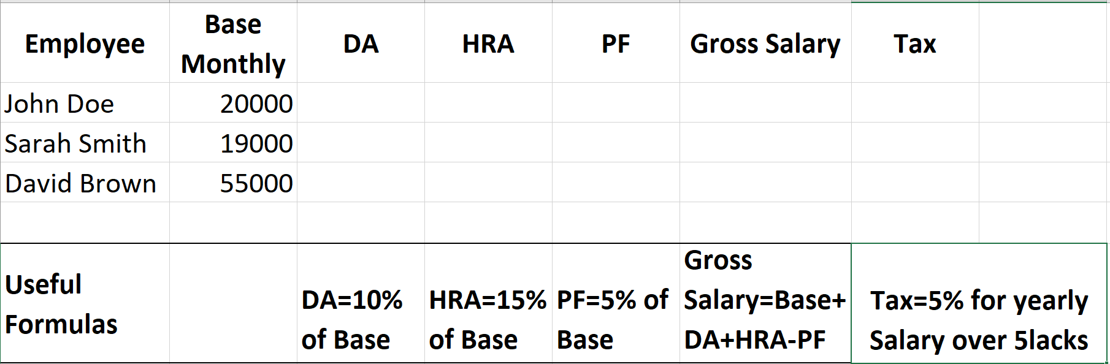

6.

**Table 1 :**

| **Employee Name** | **Employee ID** |
| --- | --- |
| John Doe | 101 |
| Sarah Smith | 102 |
| David Brown | 103 |
| Mary Johnson | 104 |

**Table 2:**

| **Employee ID** | **Employee Name** |
| --- | --- |
| 102 |  |
| 104 |  |
| 101 |  |
| 103 |  |

**1. Set Up the INDEX MATCH Formula:**

* In Table 2, find the Employee Name corresponding to the Employee ID.
* Now sort the table in ascending order of the employee name.

7.

You need to determine which employees are eligible for a year-end bonus. The eligibility criteria are as follows:

* An employee must have **at least 5 years of service** **(Years of Service >= 5)** **AND** must have a **performance rating** of **"Excellent"**.
* However, if an employee has **10 or more years of service** **(Years of Service >= 10),** they qualify for the bonus regardless of their performance rating.

**Example Data:**

| **Employee Name** | **Years of Service** | **Performance Rating** | **Bonus Eligibility** |
| --- | --- | --- | --- |
| John Doe | 7 | Excellent |  |
| Sarah Smith | 4 | Excellent |  |
| David Brown | 10 | Good |  |
| Mary Johnson | 6 | Good |  |
| James White | 12 | Fair |  |